Organizing User Search Histories
Abstract:
Users are increasingly pursuing complex task-oriented goals on the Web, such as making travel arrangements, managing finances or planning purchases. To this end, they usually break down the tasks into a few co-dependent steps and issue multiple queries around these steps repeatedly over long periods of time. To better support users in their long-term information quests on the Web, search engines keep track of their queries and clicks while searching online. In this paper, we study the problem of organizing a user’s historical queries into groups in a dynamic and automated fashion. Automatically identifying query groups is helpful for a number of different search engine components and applications, such as query suggestions, result ranking, query alterations, sessionization, and collaborative search. In our approach, we go beyond approaches that rely on textual similarity or time thresholds, and we propose a more robust approach that leverages search query logs. We experimentally study the performance of different techniques, and showcase their potential, especially when combined together.

Algorithm Used:
Page Rank Algorithms:
PageRank is a probability distribution used to represent the likelihood that a person randomly clicking on links will arrive at any particular page. PageRank can be calculated for collections of documents of any size. It is assumed in several research papers that the distribution is evenly divided among all documents in the collection at the beginning of the computational process. The PageRank computations require several passes, called "iterations", through the collection to adjust approximate PageRank values to more closely reflect the theoretical true value.
System Architecture:
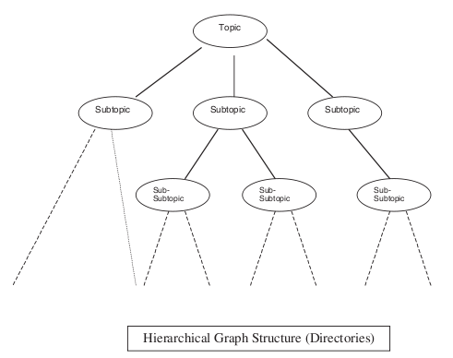
Existing System:
However, this is impractical in our scenario for two reasons. First, it may have the undesirable effect of changing a user’s existing query groups, potentially undoing the user’s own manual efforts in organizing her history. Second, it involves a high computational cost, since we would have to repeat a large number of query group similarity computations for every new query.

Disadvantages:

- We motivate and propose a method to perform query grouping in a dynamic fashion. Our goal is to ensure good performance while avoiding disruption of existing user-defined query groups.

Proposed System:
- We investigate how signals from search logs such as query reformulations and clicks can be used together to determine the relevance among query groups. We study two potential ways of using clicks in order to enhance this process by fusing the query reformulation graph and the query click graph into a single graph that we refer to as the query fusion graph, and by expanding the query set when computing relevance to also include other queries with similar clicked URLs.

- We show through comprehensive experimental evaluation the effectiveness and the robustness of our proposed search log-based method, especially when combined with approaches using other signals such as text similarity.

Advantages:
- We will focus on evaluating the effectiveness of the proposed algorithms in capturing query relevance.
- Relevance Measure
- Online query grouping process
- Similarity function

Module Description:
- Query Group
- Search history
- Query Relevance and Search logs
- Dynamic Query Grouping

System Requirement:
Hardware Requirements
- System : Pentium IV 2.4 GHz
- Hard disk : 40 GB
- Monitor : 15 VGA colour
- Mouse : Logitech.
- Ram : 256 MB
- Keyboard : 110 keys enhanced.

Software Requirements

- Operating System : Windows

- Programming language: c#.Net

- Web-Technology: ASP

- Front-End: ASP.NET

- Back-End: SQL SERVER

